Point in a Plane

Definition
# Source: AI Source: Provided by: [Data Path: Persons Table -> ID Column: 1, Name_En Column: Motasem Essam] -> From: [ChatGPT] on [7/25/2026]
A Point in a Plane is a point that lies within a given geometric plane.
If $P$is a point and $Π$is a plane, the containment relationship is written as:
$$\boxed{P∈Π}$$
This means that point $P$belongs to plane $Π$.
A plane is an infinite, flat, two-dimensional geometric surface extending without boundaries in all directions within three-dimensional space.
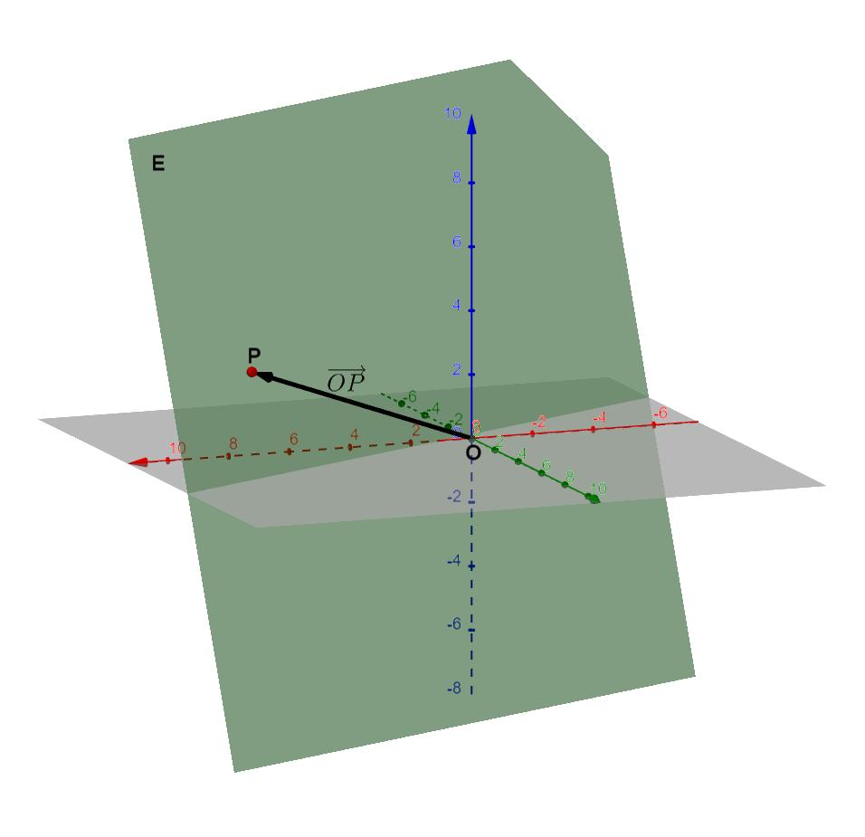
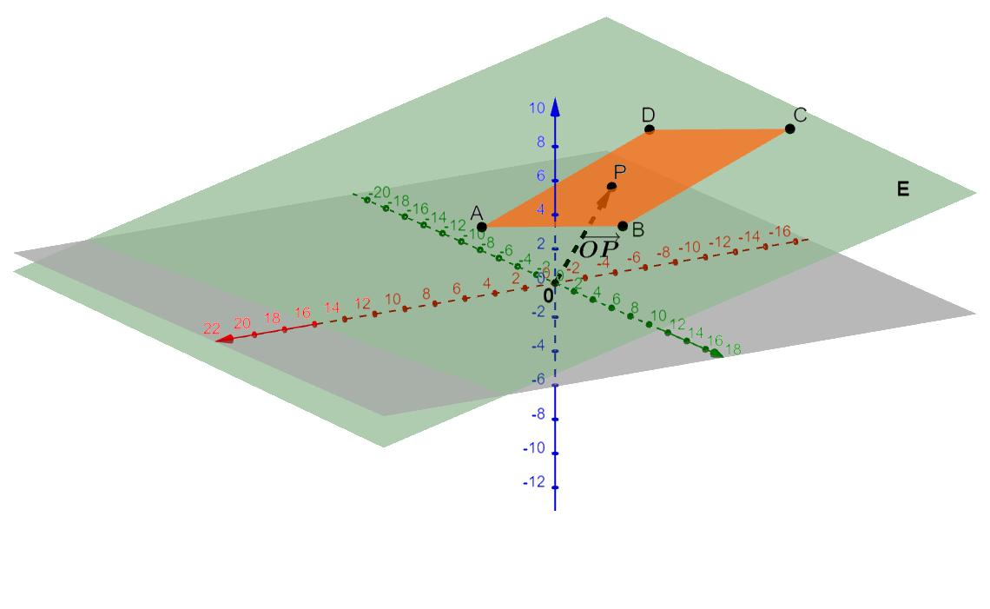
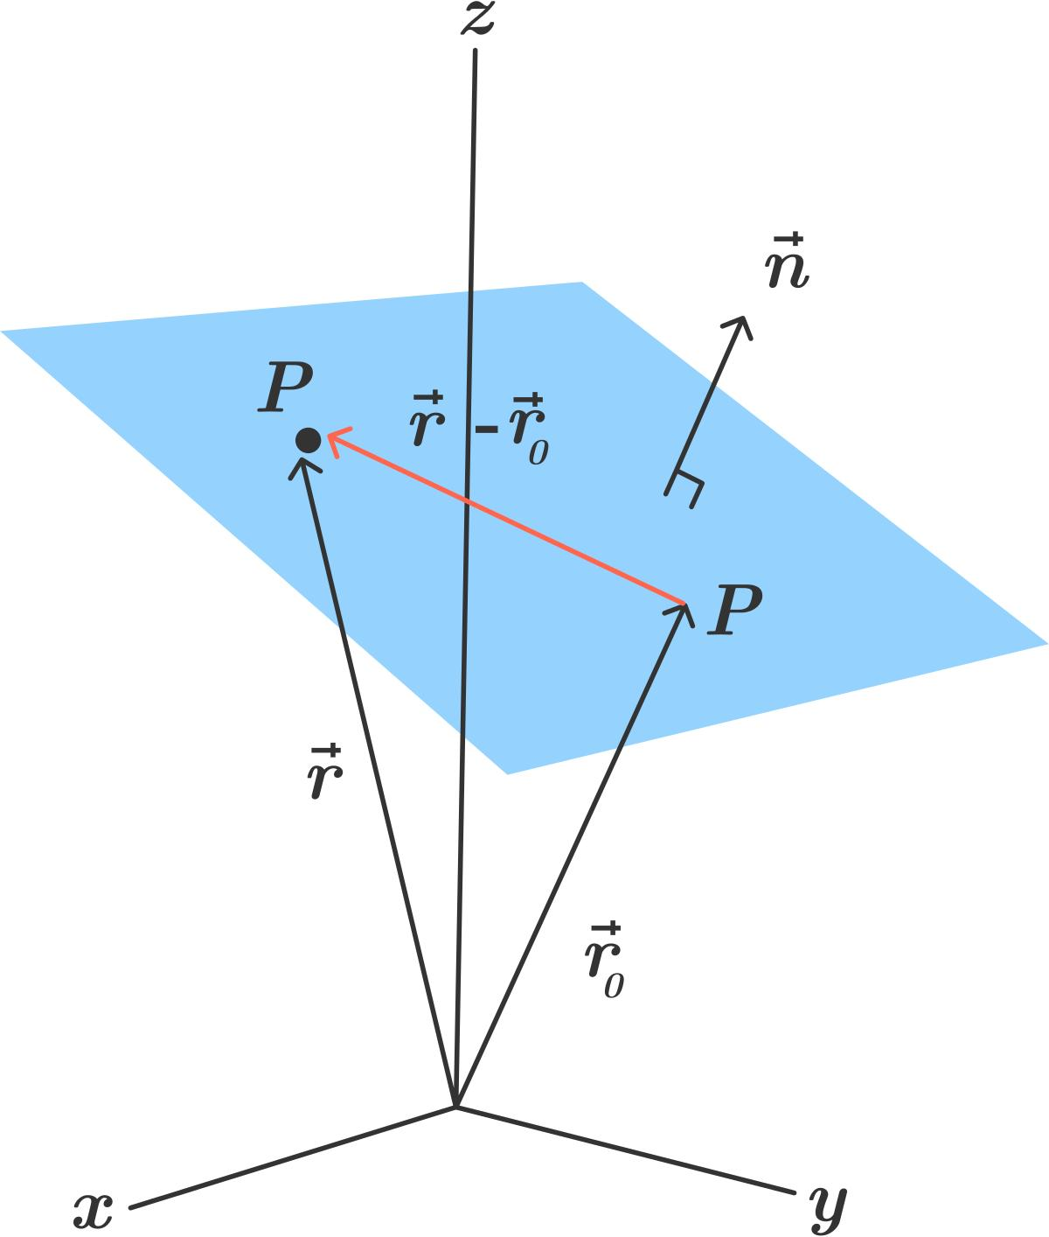
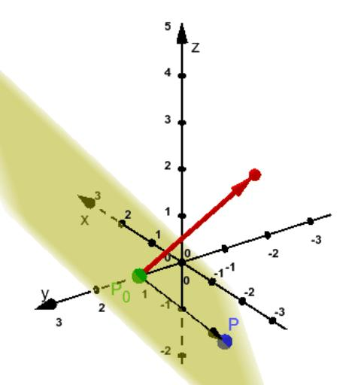

Fundamental Concept
# Source: AI Source: Provided by: [Data Path: Persons Table -> ID Column: 1, Name_En Column: Motasem Essam] -> From: [ChatGPT] on [7/25/2026]
A plane contains infinitely many points.
For example:
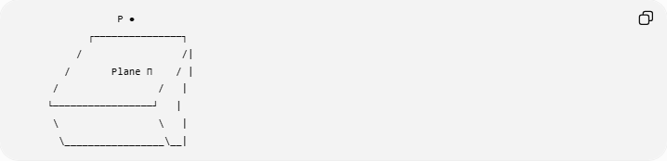
P ●
┌───────────────┐
/ /|
/ Plane Π / |
/ / |
└─────────────────┘ |
\ \ |
\_________________\__|
If point $P$lies on the plane:
$$P∈Π.$$
If it does not lie on the plane:
$$P∉Π.$$
The term "in a plane" means "contained in the plane". It does not necessarily mean that the point is inside some bounded region, because a mathematical plane has no boundary.

Mathematical Representation
# Source: AI Source: Provided by: [Data Path: Persons Table -> ID Column: 1, Name_En Column: Motasem Essam] -> From: [ChatGPT] on [7/25/2026]
A plane in three-dimensional Cartesian space can be represented by:
$$ax+by+cz=d$$
where $a,b,c,d∈R$, and at least one of $a,b,c$is nonzero.
For a point:
$$P=\left(x_{0} , y_{0} , z_{0}\right),$$
the point lies in the plane if and only if:
$$\boxed{ax_{0}+by_{0}+cz_{0}=d}$$
Example
Consider the plane:
$$2x+3y-z=6.$$
Let:
$$P=\left(1 , 2 , 2\right).$$
Substitute the coordinates:
$$2\left(1\right)+3\left(2\right)-2 \\ =2+6-2 \\ =6.$$
Therefore:
$$\boxed{P∈Π}$$
because the coordinates satisfy the plane equation.

Point Not in a Plane
# Source: AI Source: Provided by: [Data Path: Persons Table -> ID Column: 1, Name_En Column: Motasem Essam] -> From: [ChatGPT] on [7/25/2026]
Consider the same plane:
$$2x+3y-z=6.$$
Let:
$$Q=\left(1 , 2 , 5\right).$$
Substitute:
$$2\left(1\right)+3\left(2\right)-5 \\ =2+6-5 \\ =3.$$
Since:
$$3≠6,$$
we have:
$$\boxed{Q∉Π}.$$

Fundamental Elements

1. Point
# Source: AI Source: Provided by: [Data Path: Persons Table -> ID Column: 1, Name_En Column: Motasem Essam] -> From: [ChatGPT] on [7/25/2026]
A point represents a location in space.
It can be represented using three coordinates:
$$P=\left(x , y , z\right).$$

2. Plane
# Source: AI Source: Provided by: [Data Path: Persons Table -> ID Column: 1, Name_En Column: Motasem Essam] -> From: [ChatGPT] on [7/25/2026]
A plane is a flat, two-dimensional geometric object extending infinitely in three-dimensional space.
It can be represented as:
$$Π:ax+by+cz=d.$$

3. Point–Plane Containment
# Source: AI Source: Provided by: [Data Path: Persons Table -> ID Column: 1, Name_En Column: Motasem Essam] -> From: [ChatGPT] on [7/25/2026]
The fundamental relationship is:
$$\boxed{P∈Π}$$
meaning:
Point $P$is contained in plane $Π$.

4. Normal Vector
# Source: AI Source: Provided by: [Data Path: Persons Table -> ID Column: 1, Name_En Column: Motasem Essam] -> From: [ChatGPT] on [7/25/2026]
For the plane
$$ax+by+cz=d,$$
the vector
$$\vec{n}=\left(a , b , c\right)$$
is a normal vector to the plane.
The normal vector is perpendicular to every direction lying in the plane.

Geometric Interpretation
# Source: AI Source: Provided by: [Data Path: Persons Table -> ID Column: 1, Name_En Column: Motasem Essam] -> From: [ChatGPT] on [7/25/2026]
A point in a plane does not have to be at the center of the plane or inside a particular shape drawn on the plane.
For example:
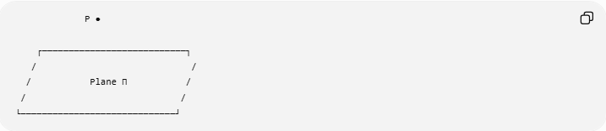
P ●

┌───────────────────────────┐
/ /
/ Plane Π /
/ /
└─────────────────────────────┘
The rectangle is only a visual representation of part of the infinite plane.
Therefore, even though $P$appears "inside" the drawn rectangle, mathematically:
$$P∈Π$$
means simply that $P$is one of the infinitely many points belonging to the plane.

Three Non-Collinear Points Determine a Plane
# Source: AI Source: Provided by: [Data Path: Persons Table -> ID Column: 1, Name_En Column: Motasem Essam] -> From: [ChatGPT] on [7/25/2026]
One of the fundamental properties of Euclidean geometry is:
Through any three non-collinear points, exactly one plane can be determined.
If $A$, $B$, and $C$are non-collinear:
$$A,B,C∈Π.$$
They determine a unique plane:
$$\boxed{Π=ABC}$$
or equivalently, the plane through $A$, $B$, and $C$.
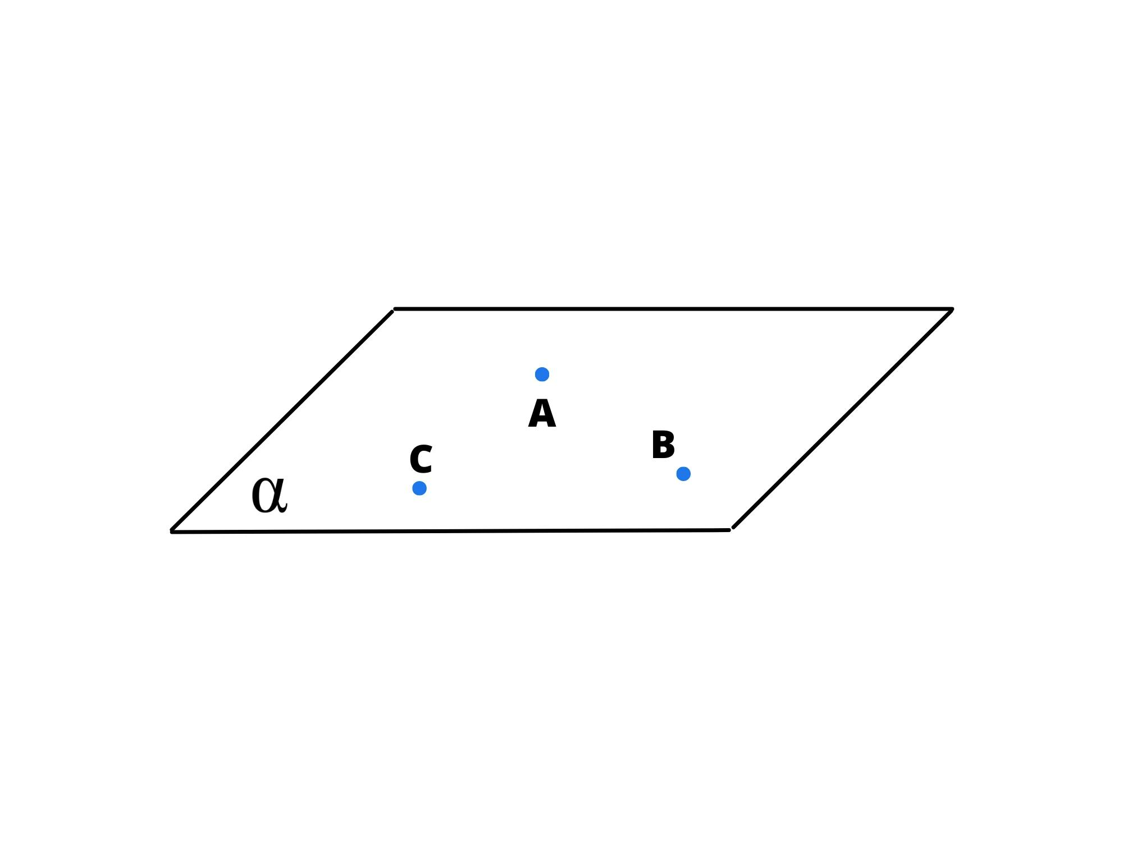
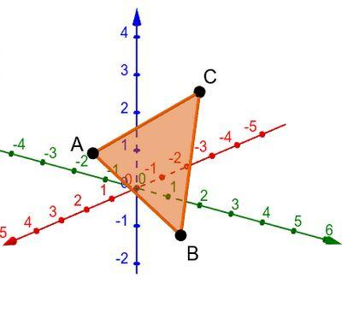
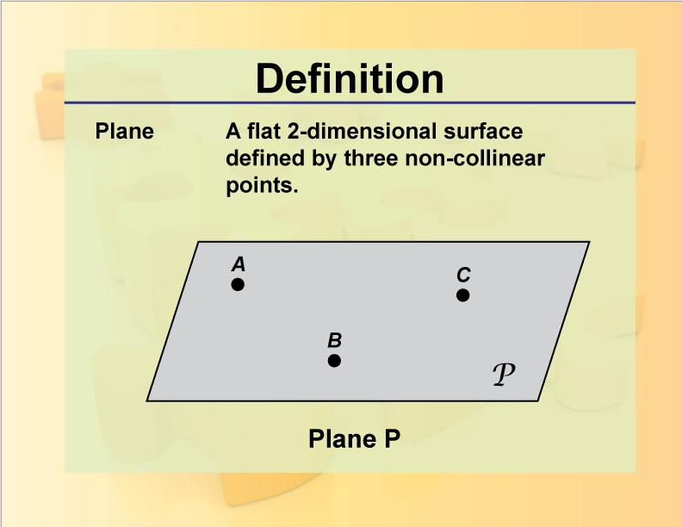
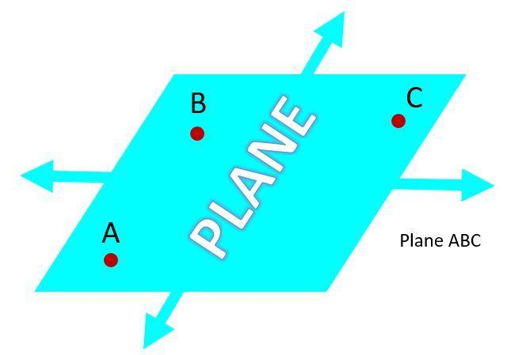

Collinear Points and Planes
# Source: AI Source: Provided by: [Data Path: Persons Table -> ID Column: 1, Name_En Column: Motasem Essam] -> From: [ChatGPT] on [7/25/2026]
Three collinear points do not determine a unique plane.
For example:
A ●────────●────────● C
B
Infinitely many planes can pass through the same line $AB$.
Therefore:
- Three non-collinear points → exactly one plane.
- Three collinear points → infinitely many planes can contain them.
This distinction is important when constructing planes from points.

Coordinate Plane Examples
# Source: AI Source: Provided by: [Data Path: Persons Table -> ID Column: 1, Name_En Column: Motasem Essam] -> From: [ChatGPT] on [7/25/2026]
The three standard coordinate planes are:

$xy$-Plane
# Source: AI Source: Provided by: [Data Path: Persons Table -> ID Column: 1, Name_En Column: Motasem Essam] -> From: [ChatGPT] on [7/25/2026]
$$\boxed{z=0}$$
A point
$$P=\left(x , y , 0\right)$$
lies in the $xy$-plane.

$xz$-Plane
# Source: AI Source: Provided by: [Data Path: Persons Table -> ID Column: 1, Name_En Column: Motasem Essam] -> From: [ChatGPT] on [7/25/2026]
$$\boxed{y=0}$$
A point
$$P=\left(x , 0 , z\right)$$
lies in the $xz$-plane.

$yz$-Plane
# Source: AI Source: Provided by: [Data Path: Persons Table -> ID Column: 1, Name_En Column: Motasem Essam] -> From: [ChatGPT] on [7/25/2026]
$$\boxed{x=0}$$
A point
$$P=\left(0 , y , z\right)$$
lies in the $yz$-plane.
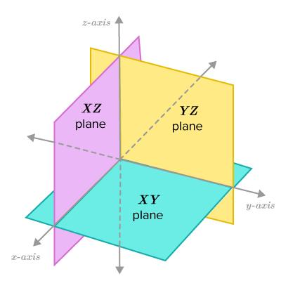
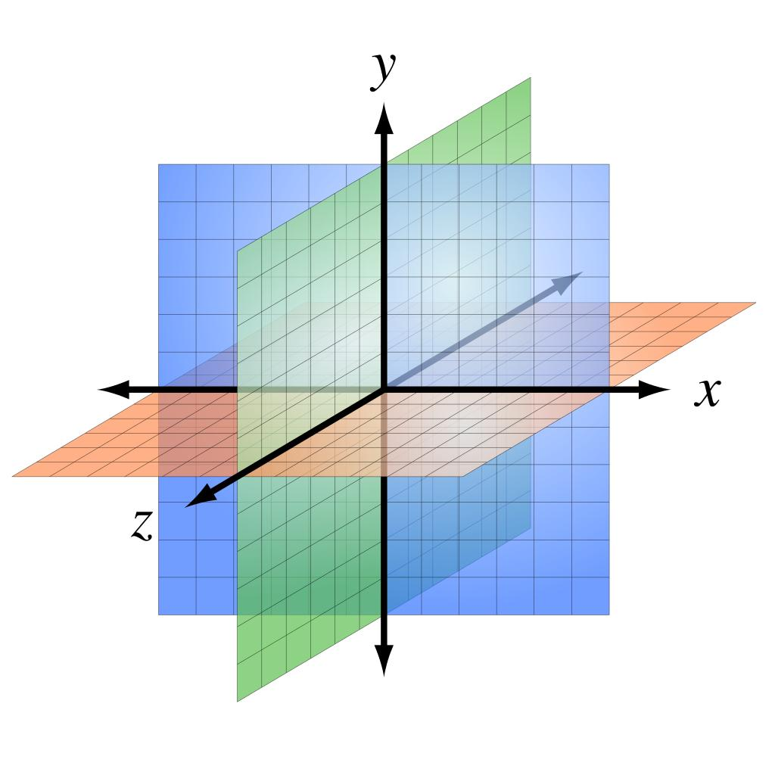
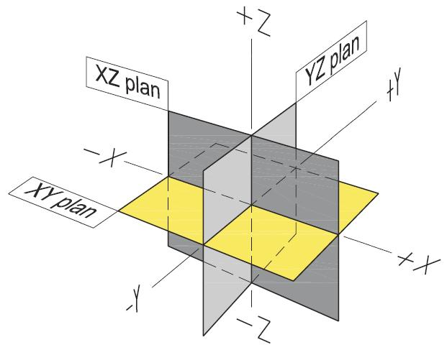

Example: Point in the $xy$-Plane
# Source: AI Source: Provided by: [Data Path: Persons Table -> ID Column: 1, Name_En Column: Motasem Essam] -> From: [ChatGPT] on [7/25/2026]
Let:
$$P=\left(4 , - , 20\right).$$
The $xy$-plane is:
$$z=0.$$
Since the $z$-coordinate of $P$is zero:
$$\boxed{P∈xy\text{-plane}}$$

Example: Point Not in the $xy$-Plane
# Source: AI Source: Provided by: [Data Path: Persons Table -> ID Column: 1, Name_En Column: Motasem Essam] -> From: [ChatGPT] on [7/25/2026]
Let:
$$Q=\left(4 , - , 23\right).$$
Because:
$$z=3≠0,$$
we have:
$$\boxed{Q∉xy\text{-plane}}.$$

Vector Representation of a Plane
# Source: AI Source: Provided by: [Data Path: Persons Table -> ID Column: 1, Name_En Column: Motasem Essam] -> From: [ChatGPT] on [7/25/2026]
A plane can also be represented using a point and two non-parallel direction vectors.
If $P_{0}$is a point in the plane and $\vec{u},\vec{v}$are non-parallel vectors lying in the plane, then:
$$\vec{r}={\vec{r}}_{0}+s\vec{u}+t\vec{v}$$
where:
$$s,t∈R.$$
Every point generated by this equation belongs to the plane.
Thus:
$$P∈Π.$$

Distance from a Point to a Plane
# Source: AI Source: Provided by: [Data Path: Persons Table -> ID Column: 1, Name_En Column: Motasem Essam] -> From: [ChatGPT] on [7/25/2026]
For a plane:
$$ax+by+cz=d$$
and point:
$$P=\left(x_{0} , y_{0} , z_{0}\right),$$
the perpendicular distance from $P$to the plane is:
$$\boxed{D=\frac{∣ax_{0}+by_{0}+cz_{0}-d∣}{\sqrt{a^{2}+b^{2}+c^{2}}}}$$
Therefore:
Point in the plane
$$D=0$$
Point outside the plane
$$D>0$$
So point containment can also be characterized as:
$$\boxed{P∈Π ⟺ D\left(P , Π\right)=0}$$

Point in a Plane vs Point on a Plane
# Source: AI Source: Provided by: [Data Path: Persons Table -> ID Column: 1, Name_En Column: Motasem Essam] -> From: [ChatGPT] on [7/25/2026]
In elementary geometry, the expressions:
- point in a plane
- point on a plane
are generally used interchangeably.
Both describe:
$$\boxed{P∈Π}$$
However, "point on a plane" is often clearer when discussing geometric incidence, because a plane is a 2D surface embedded in 3D space.
For your knowledge base, Point in a Plane is appropriate as the containment category.

Point in a Plane vs Point in a Region
# Source: AI Source: Provided by: [Data Path: Persons Table -> ID Column: 1, Name_En Column: Motasem Essam] -> From: [ChatGPT] on [7/25/2026]
These concepts should not be confused.
Point in a Plane
The plane is infinite:
$$P∈Π.$$
There is no requirement that $P$be inside a bounded area.
Point in a Region
A region is generally a bounded or otherwise specified subset of a plane.
For example, a point may be inside a circular disk:
$$x^{2}+y^{2}<r^{2}.$$
Thus:
$$\text{Point in a Region}⊆\text{Point in a Plane}$$
when the region lies in that plane.

Point in a Plane vs Point on a Surface
# Source: AI Source: Provided by: [Data Path: Persons Table -> ID Column: 1, Name_En Column: Motasem Essam] -> From: [ChatGPT] on [7/25/2026]
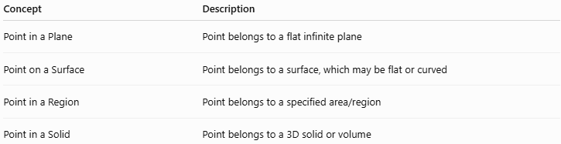
Concept | Description
Point in a Plane | Point belongs to a flat infinite plane
Point on a Surface | Point belongs to a surface, which may be flat or curved
Point in a Region | Point belongs to a specified area/region
Point in a Solid | Point belongs to a 3D solid or volume
A plane is a special type of surface, so a point contained in a plane is also contained in that plane surface.

Point–Plane Incidence
# Source: AI Source: Provided by: [Data Path: Persons Table -> ID Column: 1, Name_En Column: Motasem Essam] -> From: [ChatGPT] on [7/25/2026]
The relationship between a point and a plane is often called incidence.
If:
$$P∈Π,$$
then point $P$is incident with plane $Π$.
This is different from:
$$P∉Π,$$
where the point is not incident with the plane.
Incidence describes whether geometric objects are related by belonging or passing through one another.

Important Properties
# Source: AI Source: Provided by: [Data Path: Persons Table -> ID Column: 1, Name_En Column: Motasem Essam] -> From: [ChatGPT] on [7/25/2026]
- A plane contains infinitely many points.
- A point either belongs to a specified plane or does not.
- A point belongs to a plane when its coordinates satisfy the plane equation.
- Three non-collinear points determine exactly one plane.
- Three collinear points do not determine a unique plane.
- A line can be entirely contained in a plane.
- A plane is itself contained in three-dimensional Euclidean space:
$$Π⊂R^{3}.$$
- A point in a plane has three Cartesian coordinates, even though the plane itself is two-dimensional.

Relationship with Related Concepts
# Source: AI Source: Provided by: [Data Path: Persons Table -> ID Column: 1, Name_En Column: Motasem Essam] -> From: [ChatGPT] on [7/25/2026]
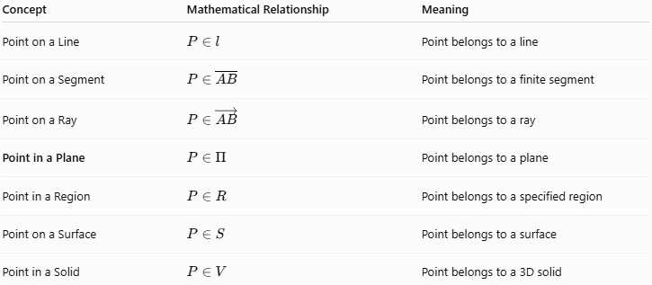
Concept | Mathematical Relationship | Meaning
Point on a Line | $$P∈l$$ | Point belongs to a line
Point on a Segment | $$P∈\overset{‾}{AB}$$ | Point belongs to a finite segment
Point on a Ray | $$P∈\vec{AB}$$ | Point belongs to a ray
Point in a Plane | $$P∈Π$$ | Point belongs to a plane
Point in a Region | $$P∈R$$ | Point belongs to a specified region
Point on a Surface | $$P∈S$$ | Point belongs to a surface
Point in a Solid | $$P∈V$$ | Point belongs to a 3D solid

Containment Hierarchy
# Source: AI Source: Provided by: [Data Path: Persons Table -> ID Column: 1, Name_En Column: Motasem Essam] -> From: [ChatGPT] on [7/25/2026]
A useful geometric containment relationship is:
$$\boxed{\text{Point}∈\text{Line}⊂\text{Plane}⊂\text{Space}}$$
For example:
$$P∈l, \\ l⊂Π, \\ Π⊂R^{3}.$$
Therefore:
$$P∈Π.$$
This shows how containment can be nested across geometric dimensions.

Key Points
# Source: AI Source: Provided by: [Data Path: Persons Table -> ID Column: 1, Name_En Column: Motasem Essam] -> From: [ChatGPT] on [7/25/2026]
- A point in a plane is a point that belongs to that plane.
- The standard notation is:
$$\boxed{P∈Π}.$$
- A general plane has equation:
$$ax+by+cz=d.$$
- A point $P=\left(x_{0} , y_{0} , z_{0}\right)$belongs to the plane exactly when:
$$ax_{0}+by_{0}+cz_{0}=d.$$
- The distance from a contained point to the plane is zero.
- Three non-collinear points determine a unique plane.
- The $xy$-, $xz$-, and $yz$-planes are the three standard coordinate planes.
- A plane is infinite, so "in a plane" does not mean "inside a bounded area."
- A plane is a special type of flat surface.
- Point-in-plane containment is a fundamental concept in Euclidean geometry, coordinate geometry, vectors, analytic geometry, and 3D geometry.

Conclusion
# Source: AI Source: Provided by: [Data Path: Persons Table -> ID Column: 1, Name_En Column: Motasem Essam] -> From: [ChatGPT] on [7/25/2026]
Point in a Plane describes the containment relationship in which a point belongs to an infinite two-dimensional plane in three-dimensional space. The relationship is represented by $P∈Π$, and in coordinate geometry it can be verified by substituting the point's coordinates into the plane equation. This concept is fundamental for understanding planes, lines contained in planes, coordinate planes, spatial geometry, incidence, and higher-dimensional geometric containment.

